

How to Download and Install Docker, and Create a Stack for MQTT Broker and Node-RED

Docker Desktop is a user-friendly application that enables to build, share, and run containerized applications on the local machine. It provides a complete environment for working with Docker containers, making it easy to manage and deploy applications across different environments.

# 1. How to Download and Install Docker

## 1.1 Downloading Docker

1. Visit the Docker Website:  
 - Go to the official Docker website: https://www.docker.com/get-started.

2. Select Your Operating System:  
 - Choose the appropriate version for your operating system:  
 - Windows  
 - macOS  
 - Linux

## 1.2 Installing Docker on Windows

1. Download Docker Desktop Installer:  
 - Download the Docker Desktop installer `.exe` file.

2. Run the Installer:  
 - Open the `.exe` file and follow the installation instructions.

3. Enable WSL 2 (Windows Subsystem for Linux):  
 - Make sure WSL 2 is enabled during setup. Install it if required.

4. Launch Docker Desktop:  
 - After installation, launch Docker Desktop, accept the Term of Service, and skip the rest until the Program is ready.

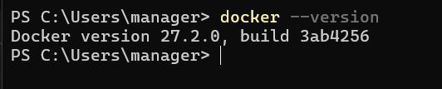5. Verify Installation:  
 - Open a command prompt and type:  
 docker --version

## 1.3 Installing Docker on macOS

1. Download Docker Desktop Installer:  
 - Download the `.dmg` file for macOS.

2. Install the Application:  
 - Drag Docker into the Applications folder.

3. Launch Docker Desktop:  
 - Open Docker from the Applications folder.

4. Verify Installation:  
 - Open terminal and type:  
 docker --version

## 1.4 Installing Docker on Linux

1. Update Your Package List:  
 - Run:  
 sudo apt-get update

2. Install Required Packages:  
 - Run:  
 sudo apt-get install apt-transport-https ca-certificates curl software-properties-common

3. Add Docker’s GPG Key:  
 - Run:  
 curl -fsSL https://download.docker.com/linux/ubuntu/gpg | sudo apt-key add -

4. Set Up the Docker Repository:  
 - Run:  
 sudo add-apt-repository "deb [arch=amd64] https://download.docker.com/linux/ubuntu $(lsb_release -cs) stable"

5. Install Docker CE:  
 - Run:  
 sudo apt-get update  
 sudo apt-get install docker-ce

6. Verify Installation:  
 - Run:  
 docker –version

# 2. How to Create a Docker Stack Running MQTT Broker and Node-RED

## 2.11 Setting Up a Docker Compose File (Windows)

To facilitate a quick setup, there are two .bat Files included:  
Once Docker Desktop is up and Running, and you see this:

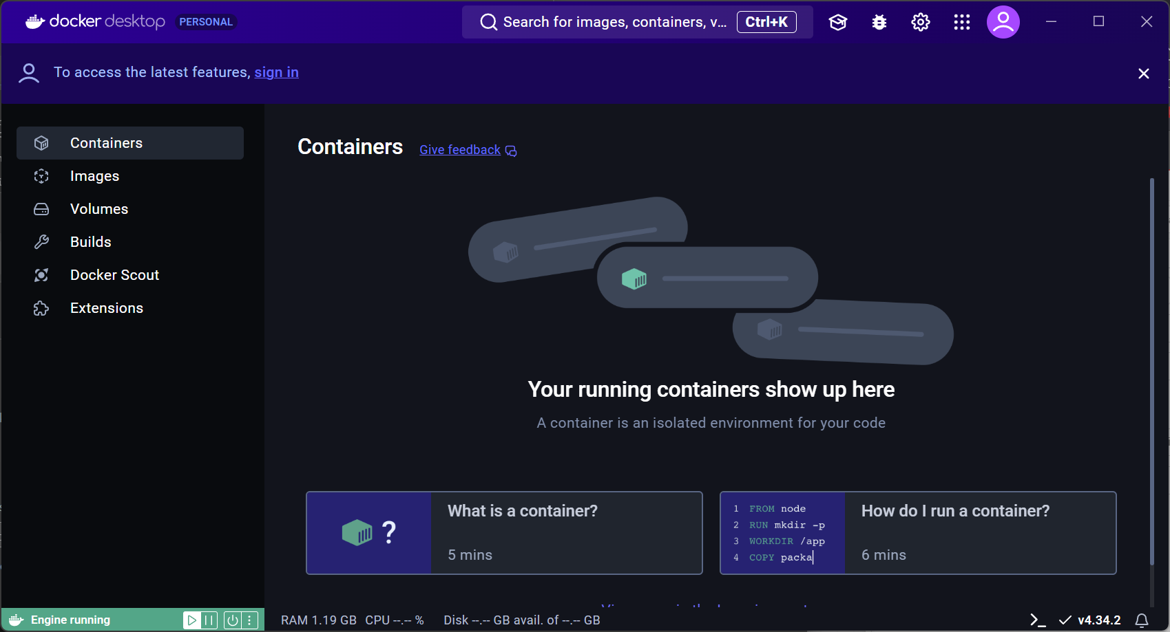

Then you can start register_stack.bat and follow the Instructions. It will register the two pre-made Docker Containers after downloading the official Images.

After completion, your Window should look like this:

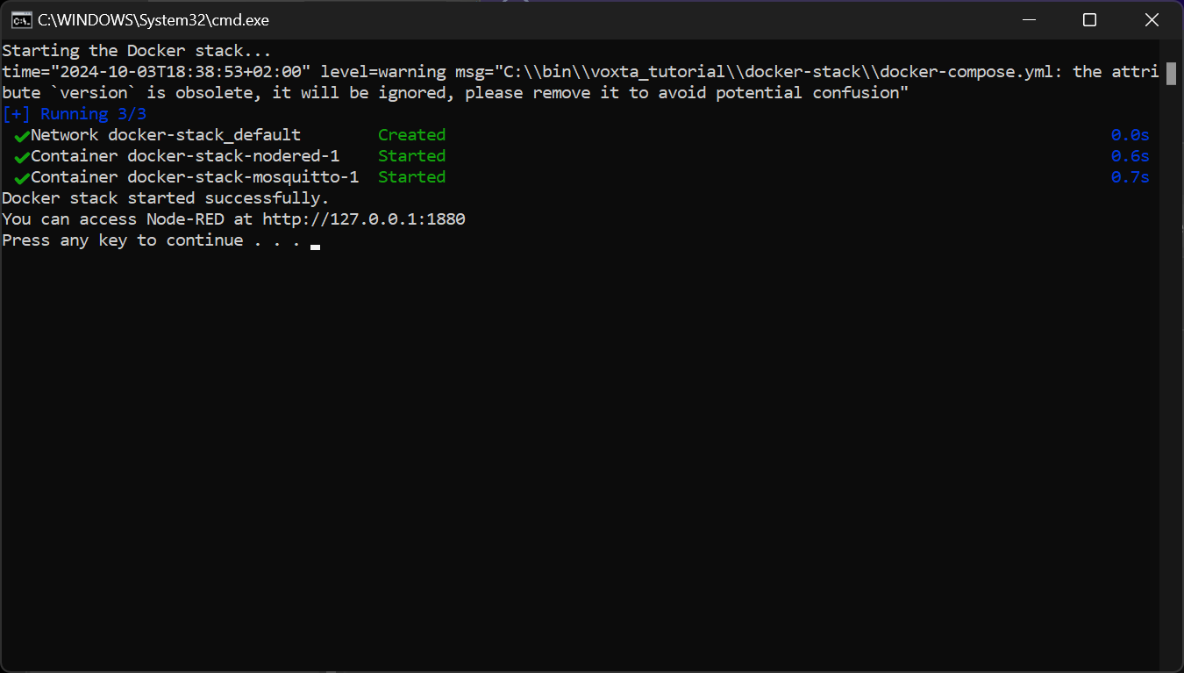

## 2.12 Accessing the Services (Windows)

1. To access Node-RED, open a web browser and enter:

`http://localhost:1880`

This is where you can access the Node-RED flow editor.

You should see the Example Flow now 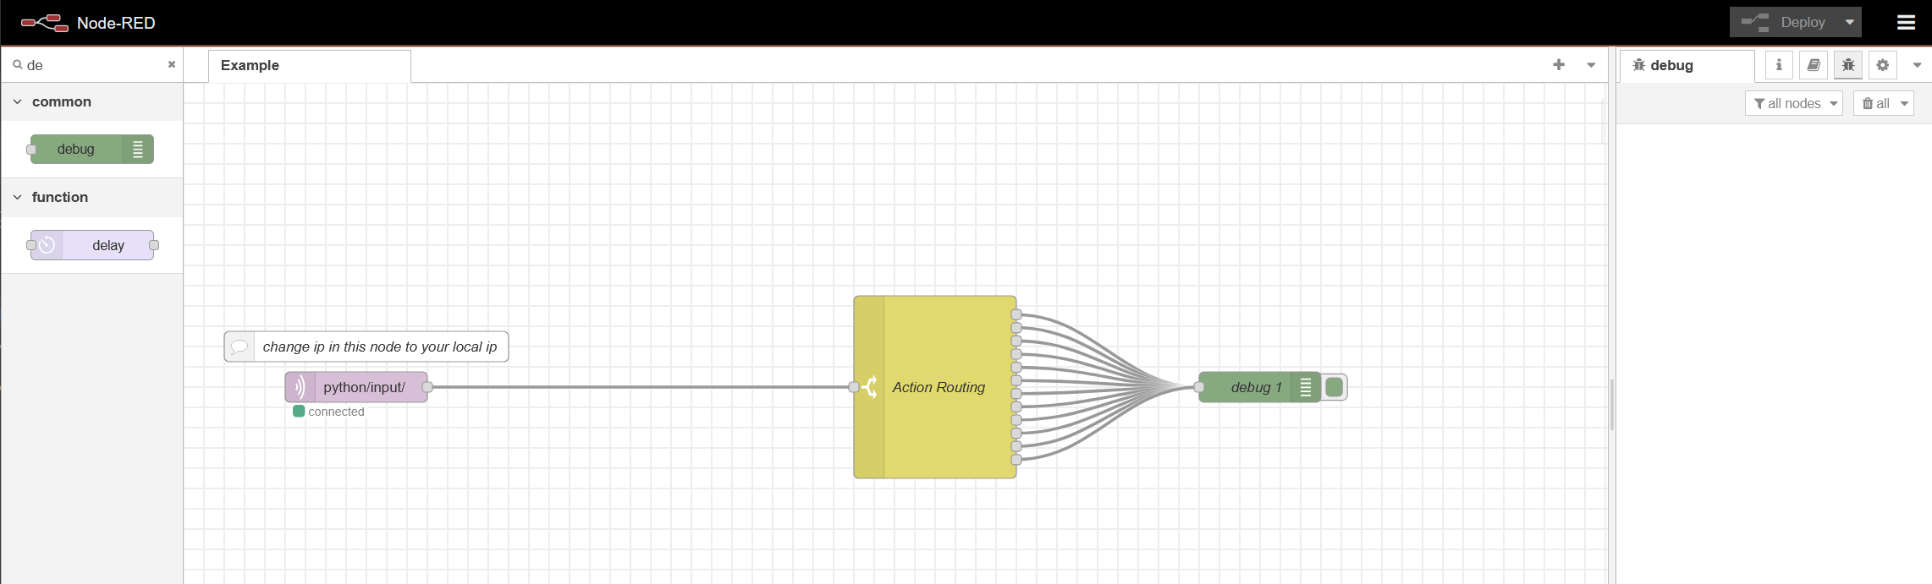

~~Edit the Server IP Adress to your local one. You can optain this Information either from the Console that opened with start_ProviderAPP.bat or you open a Command Console in Windows via Start -> CMD and enter in the Console: ipconfig~~

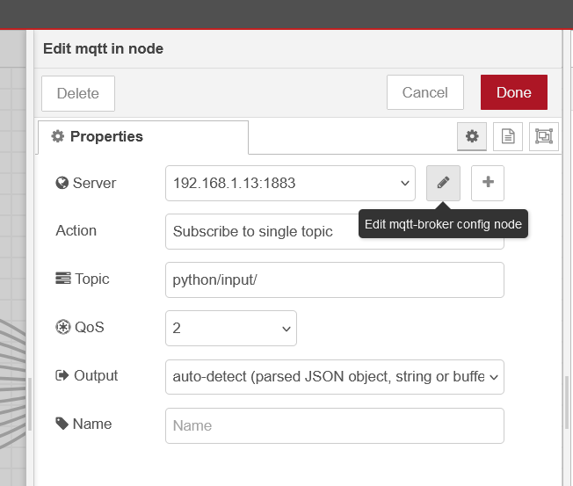

***Only necessary for Server Installation of existing HOIT!***

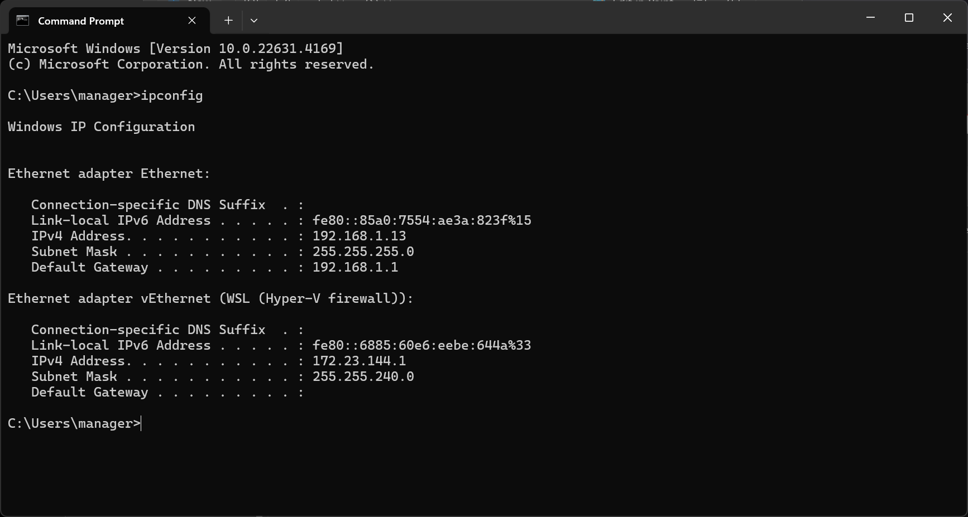

## 2.21 Setting Up a Docker Compose File (Linux)

1. Create a Working Directory:  
 - Run:  
 mkdir mqtt-nodered-stack  
 cd mqtt-nodered-stack

2. Create the docker-compose.yml File:  
 - Run:  
 nano docker-compose.yml

3. Define the Stack (copy content the created File):

version: '3.8'  
  
services:  
 mosquitto:  
 image: eclipse-mosquitto:latest  
 ports:  
 - "1883:1883" # MQTT port  
 - "9001:9001" # WebSockets port  
 volumes:  
 - ./mosquitto/config:/mosquitto/config  
 - ./mosquitto/data:/mosquitto/data  
 - ./mosquitto/log:/mosquitto/log  
 restart: always  
  
 nodered:  
 image: nodered/node-red:latest  
 ports:  
 - "1880:1880" # Node-RED dashboard port  
 volumes:  
 - ./nodered/data:/data  
 restart: always

4. Save and Exit the File:  
 - Save the file and exit the editor.

## 2.22 Launching the Stack (Linux)

1. Run the Docker Compose Command:  
 - Run:  
 docker-compose up -d

2. Check if Containers are Running:  
 - Run:  
 docker ps

## 2.23 Accessing the Services (Linux)

1. Node-RED:  
 - Go to:  
 http://localhost:1880

2. MQTT Broker:  
 - The MQTT broker is running on port 1883 (MQTT clients) and 9001 (WebSockets).

## 2.4 Stopping the Stack (Linux)

To stop the services, run:  
 docker-compose down